**Assignment 26.5**

**Problem Statement:**

How many kinds of tables are present in hive and explain the difference between them with a demo.

**Answer:**

In Hive we can create two types of tables as:

* EXTERNAL TABLE
* INTERNAL TABLE

This is a choice that affects how data is loaded, controlled, and managed.

**EXTERNAL tables:**

The external tables are preferable when data is also used outside of Hive. For example, the data files are read and processed by an existing program that doesn’t lock the files.

Data needs to remain in the underlying location even after a DROP TABLE. This can apply if you are pointing multiple schemas (tables or views) at a single data set or if you are iterating through various possible schemas.

You want to use a custom location such as ASV.

Hive should not own data and control settings, dirs, etc., you have another program or process that will do those things.

You are not creating table based on existing table (AS SELECT).

**Demo:**

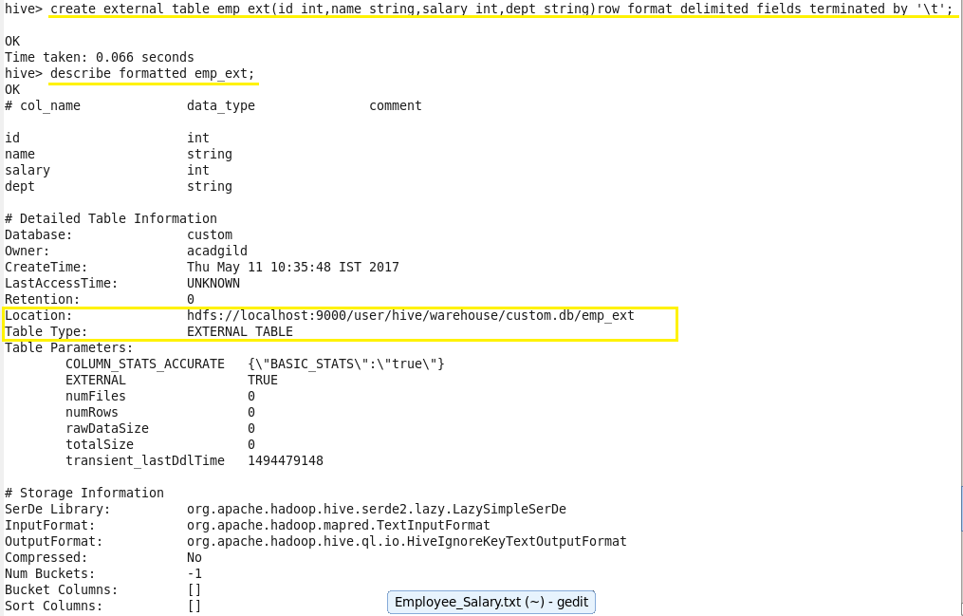

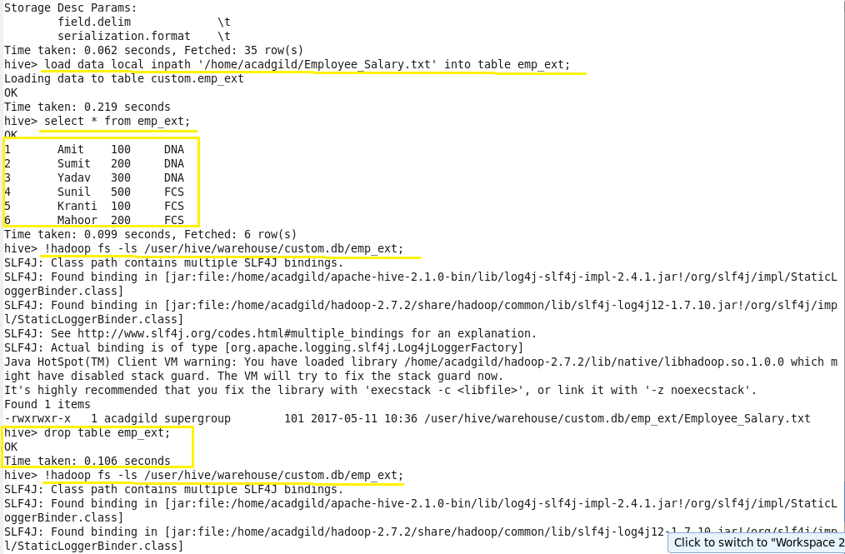

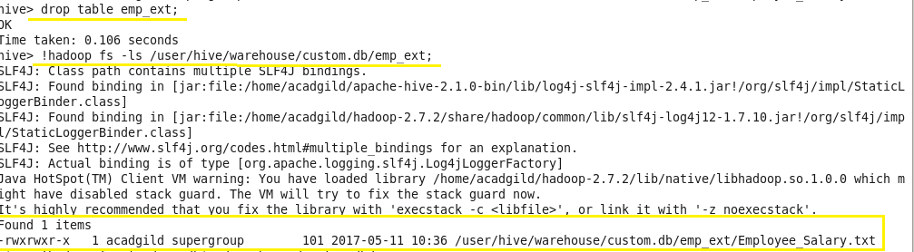

**INTERNAL tables:**

The internal tables should be used when data is temporary.

You want Hive to completely manage the lifecycle of the table and data.

**Demo:**

